

Primary Five
ICT
Name:
Class:

1st Term
Information and Communication Technology

Primary 5
First Term
ICT Binder
2026-2027

Name:……………………………………………………
Class:…………………………………………
Theme 1
Lesson 1
Computer Accessories
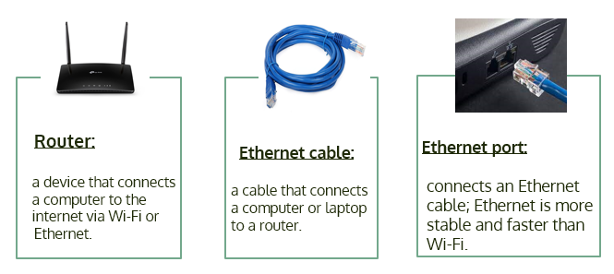

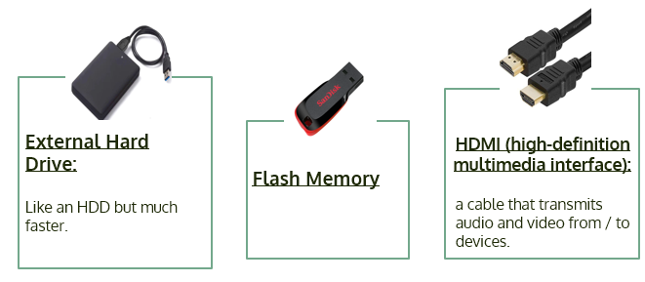

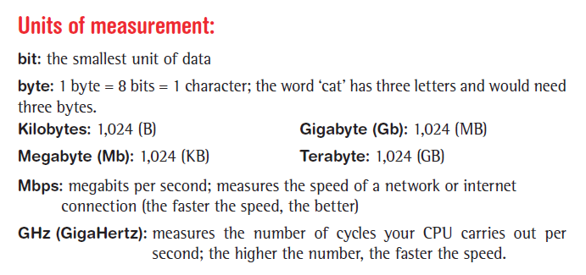

Potential Computer Problems and Solutions
Problem 1: Trouble processing large files, like a large PowerPoint
presentation
Potential reason: Not enough graphics storage
Solution: Shut down some programs.
Problem 2: A poor video-conference connection
Potential reason: Slow wireless internet connection
Solution: Try an Ethernet connection.
Problem 3: Not able to store files
Potential reason: Not enough space
Solution: Move old files to an external drive
Problem 4: Home internet connection not working
Potential reason: Connection interrupted
solution: Use Ethernet or contact ISP
Questions
Q1: Put ( ) or ( ):
- Bit is the smallest measuring unit for storing data. ( )
- When there is a problem in processing large files, some programs should be closed. ( )
- The external hard disk is used to store files with large space. ( )
- You can’t create backup copies of files. ( )
- 1 Terabyte = 1029 Megabytes. ( )
- 1 Kilobyte = 1030 Bytes. ( )
- 1 Gigabyte = 1024 Megabytes. ( )
- An ethernet cable is a device that connects a computer to the Internet via Wi-Fi. ( )
- A flash memory is a wire that connects the computer to the router. ( )
- There are no solutions to the problems that you may face while using the computer. ( )

Q2: Choose the correct answer:
- To solve the problem of slowing down your computer, ………………… then restart it.
a. update apps b. turn off the device c. check the Wi-Fi
- When deleting some unwanted applications, it leads to …………
a. device slowness b. speed of device performance c. software update
- If the Internet is running slowly, check ………………………...
a. connecting to Wi-Fi
b. connecting the printer
c. connecting the monitor
- ………...is one of the electronic accessories that are used for storage.
a. Printer b. Wi-Fi c. Flash Memory
5. One of the steps to solve the problem is to………………… the
problem.
a. ignore b. cancel c. define

Lesson 2
Networks
Networks are group of people or things that are connected to each other for a common purpose.

Computer networks connect computers with each other to share important information and data.

You may have your own personal computer network at home.
If you have a computer connected to another computer or device such as a printer or a router, then you have a LAN (Local Area Network ).
Internet:
It is a network that connects computers and people using them to others all over the world.
World Wide Web (WWW):
It is a part of the Internet network and made up of webpages that people can navigate.
Egyptian Knowledge Bank website (EKB) is a part of WWW and it is available for free to all Egyptians who register on the site.
We need a Gateway like a router to connect the computer to the Internet service provider (ISP).
ISP: It is the companies that provide citizens with the internet service.

Intranet:
It is a private network, and it is restricted to only those people who work in the same organization.

Questions
Q1: Put ( ) or ( ):
  - An intranet network connects computers and people who use that network from all over the world. ( )

  - The Internet is a private network that is restricted to the people you connect with within a specific institution. ( )

  - The World Wide Web is the gateway that connects a computer to the Internet. ( )
  - Gateway is used to connect a computer to the Internet. ( )
  - The closed network is the one that may belong to the computer lab in a school. ( )

  - The Egyptian Knowledge Bank does not exist on the World Wide Web. ( )
  - The Egyptian Knowledge Bank is available for free to Egyptians. ( )
  - The router connects the computer to the Internet service provider (ISP). ( )
  - The Internet is a limited network. ( )
  - WWW is made up of webpages that people can navigate. ( )

Q2: Choose the correct answer:
- The Internet is …………………….. computer network.
a. a closed b. an open c. a limited
- ………………. is a network used to share information and is less secure.
a. E-mail b. Intranet c. Internet
- WWW stands for………………
a. World Wide Wi-Fi b. World Wide Web c. World White Web
- To connect your computer to the Internet, you need a gateway such as a …………
a. scanner b. router c. printer
- A ………….. is a long connector that transmits data or power between devices.
a. flash memory b. Bluetooth c. cable

Lesson 3
Smart Communication System
Internet of Things (IoT)
- It consists of devices linked to the internet via Wi-Fi.
- You can control it whether you are in the same room or in another city. For example:
Bluetooth speakers.
The refrigerator or washing machine can be turned on and off using an application.

Bluetooth:
- It is a network technology that connects wireless mobile devices over a short range to transmit data.
Computer networks and people of determination
Computer networks give people of determination independence, whether at home or in public places, and help them save money and time and increase their level of self-confidence.
Networks and people of determination:

E-commerce:
- Online buying and selling.
- Permission must be obtained from our parents before purchasing anything online.
- You must be careful when giving your information to anyone and this is called (digital privacy).

Screen Readers:
- Used for audio feed back and for help with reading braille.
- Help visually impaired people to write papers and open documents on their laptops.

Questions
Q1: Put ( ) or ( ):
- You can share photos with colleagues using your mobile phone. ( )
- The Internet connects wireless mobile devices over a short range. ( )
- Braille makes it difficult to read for people of determination. ( )
- ICT tools help people of determination accomplish their daily tasks easily. ( )
- There are no household gadgets that can connect to the Internet. ( )
- Screen readers help people of determination to read research papers. ( )
- Bluetooth is a network technology that works over long ranges. ( )
- Through the Internet, the largest number of people can be reached. ( )
- The Egyptian Knowledge Bank contains a lot of interesting information. ( )
- Screen readers are used to obtain audio feedback. ( )

Q2: Choose the correct answer:
- You can share photos with your friends using ……………………... a. mobile phones b. earphones c. microphones
- Household items can be a part of a network and this is called the ……………….
a. Internet of Things b. Gadgets c. Tools
- The IoT consists of devices linked to the Internet via …………
a. e-mail b. Wi-Fi c. Intranet
- ……………is a network technology that connects wireless mobile devices over a short range to form a network.
a. Internet b. Wi-Fi c. Bluetooth
- We communicate using …………………….…….every day.
a. websites b. e-mail c. computer networks

Lesson 4
Internet Connection Problems and Solutions

How to solve the problems you face while using the computer?
1. Identify the problem.
- What is the issue?
- Is it a hardware or software problem?
- Have you committed an error that causes the problem?
2. Think about and plan different ways to solve the problem.
3. Go through your potential solutions to the problem.
Try each one until you find a solution or get to your final idea without solving it.
4. Which solutions worked?
- If you didn't solve the problem, what did you learn while trying?
- How can what you learned help you the next time you try to solve a problem?
5.Ask your teacher or a member of your family for help.
Common computer problems and solutions:
Problem: The computer slows down when opening an app.
Possible solutions:
- Shut down and restart.
- Check for software updates.
- Delete unwanted apps.

Problem: The browser is running slowly.
Possible solutions:
- Check Wi-Fi signals.
- Make sure to update the apps on your device.

Problem: No internet connection.
Possible solutions:
- Use the software to troubleshoot your Wi-Fi connection.
- Check that the router is connected.
- Restart your router.
- Try a new Ethernet cable.
- Contact the customer service of your ISP for help.

Problem: It’s slow to download
Possible solutions:
- Restart the computer and the router.
- Check internet speed.

Questions
Q1: Put ( ) or ( ):
- Checking the connection to Wi-Fi is one of the possible solutions to the slow performance of the search engine. ( )
- You cannot solve any problem that may appear while using the computer. ( )
- It is important to ask for help from your teacher or one of your family members when browsing a website for the first time. ( )
- There are no organized steps for finding solutions to Internet problems. ( )
- A Word processing program (Word) is used to present information. ( )
- Spreadsheet program (Excel) may be used in calculations. ( )
- Video conferencing is used to share videos with others. ( )
- Apps on your computer should always be updated. ( )
Q2: Choose the correct answer:
  - The first stage of problem solving is ………………..…
a. planning different ways b. asking for help c. defining the problem
  - If you do not find a solution to the computer problem, you should ask …….……..for help.
a. your teacher b. member of your family c. (a or b)
  - We use …………………. to create presentations.
a. Excel b. PowerPoint c. Word
  - We may use e-mail and ……………….. to share the presentations with our colleagues.
a. Excel b. video conferencing c. PowerPoint
Q3: Match:

A  Problem |  | B  Solution
1 | Slow to download. | A | Shut down and restart; check for software updates; delete unwanted apps.
2 | The browser is running slowly. | B | Use the software to troubleshoot your Wi-Fi connection; check that the router is connected and restart it.
3 | The computer slows down when opening an app. | C | Restart the computer and router; check the internet speed.
4 | No internet connection. | D | Check Wi-Fi signal; make sure to update the apps on your device.

Lesson5
Digital File Management
How and where do you save and store information?
- Use image scanners and save the images for later use.
- Store and share information with Flash Memory.
How To Get Organized Using ICT Tools
- Create the main folder.
- Add sub-folders.
- Give each file a name.
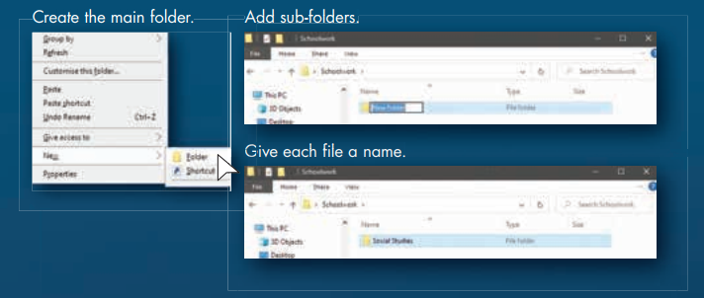
- Place documents, images, and videos in the correct folder.

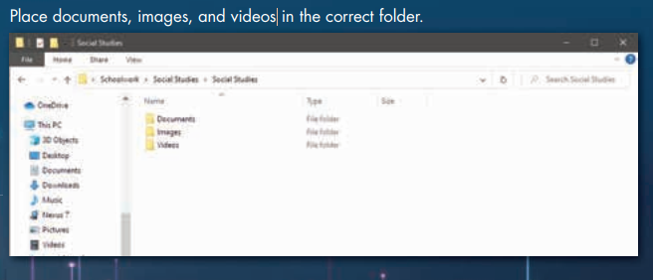

Questions
Q1: Put ( ) or ( ):
- The operating system doesn’t allow you to add a sub-folder inside the main folder. ( )
- Protecting files and storing them on different devices is not necessary. ( )
- Select “New” from “File” to create a new folder. ( )
- The management of files on the computer is limited to videos only. ( )
- Data should be organized in the computer to find it easily later. ( )
- Each folder must be given a unique title. ( )
- To change the title of a folder, choose the “Delete” command. ( )
- Choose the “Open” command to add sub-folders. ( )
- We cannot add a sub-folder to the main folder. ( )
- To create a new folder, right click in the place where you want and select “New”, then “Folder”. ( )

Q2: Choose the correct answer:
- The ………………………...is used to add pictures and files on a device.
a. keyboard b. printer c. scanner
- Select ……... from the shortcut menu to create a new folder.
a. Paste b. New c. Copy
- It is better to choose a suitable name for each……………. indicating its content.
a. folder b. program c. application
- To change the title of a folder, choose …………........ command.
a. Rename b. New c. Save
- To open a folder, select …………………..
a. Open b. Delete c. New

Lesson 6
Sharing Information
Communicating with ICT tools
- Create graphs or charts to share information.
- When sharing information online, you must decide which information should be shared.
- The internet is used to share over the web and is less secure.
- An intranet is used to share in a closed network and is more secure.

Using Microsoft Excel
- Sorting info in alphabetical order:
- Go to the toolbar and click on Data.
- Click on Sort.
- Setting Formulas in cells:
- Click on the cell where you want to set a formula.
- Type “=“ in the Formula Bar.
- Decide which cells are in your formula.
- The cell reference is the letters at the top of columns
and the numbers to the left of the rows.
- Choose:
(+) to add, (-) to subtract, (*) to multiply, or (/) to divide.

Example 1:
If you want to add the data from columns A, B, and C, row 8, you should type the following in the formula bar:
= A8+B8+C8

Example 2:
If you want to add numbers from the same column (A), but different rows (4-6), the column’s title would still come first:
= A4+A5+A6

Questions
Q1: Put ( ) or ( ):
- The symbol / is used to perform the division operation in the Excel program. ( )
- Information tables can be created through the Excel program. ( )
- Row title is the number at the left of the row. ( )
- For sorting information in alphabetical order, click “Copy”. ( )
- The Excel program includes many formulas and functions that help in performing calculations. ( )
- Column title is the letters at the bottom of the column. ( )
Q2: Choose the correct answer:
- The cell in the Excel program can contain texts or ……………………
a. numbers b. equations c. (a and b)
- ………... program is used to create mathematical tables and graphs.
a. Google Chrome b. Excel c. Paint
- Sharing information over the Internet is considered ………………....
a. more secure b. less secure c. safe
- To create a formula in Excel, click on the cell and type ………………...
a. " " b. = c. ( )
- ………….. program is used to perform simple formulas.
a. PowerPoint b. Zoom c. Excel
- ………………...program is used to prepare graphs.
a. Excel b. Word Processor c. Zoom
- In the Excel program, for sorting information in alphabetical order, go to the……...... toolbar.
a. Data b. Insert c. View
- You can set formulas in cells to multiply by using the following sign:…………….
a. + b. - c. *
Theme 2
Lesson 1
Methods of Protecting Data and Information
Stolen data
- Hackers use the internet to break into a computer system and steal personal information, such as:
your name, address, date of birth, and your passwords.
- This personal information is called Personally Identifiable Information (PII).
- A hacker can:
Use someone’s email address and password to send a virus to all the email addresses in your email account.
Use an adult’s bank account number to take money from that account.

To keep your PII safe:
Limit the personal information you share online.
- Don’t sign up for a website if it asks for too much personal information.
- Use different strong passwords that contain letters, numbers, and special signs.
- Use antivirus software on all of your devices
- Update your devices regularly.

- Protect the files
Some apps and software programs back up data automatically.
You can use a data-storage device that you attach to your computer, such as a flash drive or an external hard drive. This is called a hybrid backup.
An external hard disk is used to save your files securely and backup copies of your files.
The hard disk has more space than the Flash Memory.
Questions
Q1: Put ( ) or ( ):
- Antivirus software must be installed on your device. ( )
- Limit the personal information you share online. ( )
- Don’t sign up for a website if it asks for too much personal information. ( )
- The storage space of the hard disk is always smaller than the flash memory. ( )
- It is not recommended to use antivirus software on your device. ( )
- Some apps and software programs back up data automatically. ( )
- It is necessary to sign up for websites that ask for a lot of personal information. ( )
- We cannot keep our Personally Identifiable Information (PII) secure. ( )
- There is no way to create a backup of your files. ( )
- One of the ways to protect your files is to limit the personal information you share online. ( )
Q2: Choose the correct answer:
- Hackers can send a…………………………………...
a. gift b. virus c. reward
- Use ………………... passwords for different sites to keep your information safe.
a. the same b. weak c. different
- Backup copies of files are created on ……………...
a. flash memory b. external hard disk c. both of them
- Using a data-storage device that you attach to your computer is called……………..
a. hybrid backup b. copying files c. storing data
- The ……………has more space than the Flash Memory.
a. router b. hard disk c. cable
Q3: Complete from words between brackets:
(Antivirus software - hacker- address- your passwords- protect)
  - Personal information means, your name, date of birth, and ............

  - You should know how to........................ the files that you create or store on a device.

  - Hackers use the Internet to break into computer systems and steal ……………..

  - Using ............................ on all of your devices keeps your personal information safe.

  - A………………... can use an adult's bank account number to steal his money.

Lesson 2
Managing Passwords

Reasons to protect your password:
- There are many ways hackers can get your password
password.
- One way is called phishing.
Phishing:
- Is sending a message via e-mail or social media applications that looks real, but isn't, to steal your data and personal information.

- One type of phishing scam is a message that says that you have won a prize, but you have to give your bank account details to get the prize. Another encourages you to act quickly.

- Ways of identifying such messages include misspelled words, grammar errors, or requests for too much personal data.
Smishing is the same thing, but it is a text message instead of an email.

Password managers
- You need strong passwords to protect your personal data from hackers.
- A password manager creates a strong, unique password for each of your accounts.
- It also tells you if the passwords you already have are too weak or if you’ve reused them.
- It can even tell you if one of your passwords has been stolen online.

Multi-factor authentication (MFA)

- It is used to strengthen your passwords.
- It is used to identify yourself using at least two ways.
- It is used to prevent hackers from accessing your account and data by combining your password or personal identification number (PIN) with sending an email or a one-time code (verification code).

Questions
Q1: Put ( ) or ( ):
- Password manager software is used to create strong passwords. ( )
- The password manager program allows users to provide user passwords. ( )
- Strong passwords must contain only letters and numbers. ( )
- The password mustn’t be more than 4 numbers. ( )
- The password must be strong. ( )
- You do not need strong passwords to protect your personal data from hackers. ( )
- A password manager can tell you if one of your passwords has been stolen online. ( )
- There are many ways hackers can get your passwords; one way is called phishing. ( )
- You can recognize phishing messages as they contain grammatical errors. ( )
- Passwords can be strengthened through Multi-Factor Authentication. ( )

Q2: Choose the correct answer:
- One of the forms of ………….…..is the arrival of a message from an unknown person asking you for your data to obtain a prize.
a. Internet b. phishing c. password manager
- Smishing means sending a …………… says that you have won a prize.
a. pictures b. video c. text message
- The………………..tries to obtain the bank account number of an adult to steal his money.
a. programmer b. hacker c. password manager
- An example of phishing is the arrival of a message ……………...from an unknown person.
a. to shut down your computer
b. that you won a prize c. to call someone
Q3: Complete from words between brackets:
(grammar errors - stolen online - Phishing - password manager)
- A …………………. creates a strong unique password for each of your accounts.
- ……………………. is sending a message via e-mail or social media applications, that looks real, but isn't.
- You can identify phishing messages, they contain a lot of………..….. , or request too much personal data.
- A password manager can tell you if one of your passwords has been ………….

Lesson 3
Dealing with Official Electronic Websites

Scam Websites
- Some websites are scam websites.
- These websites can be phishing websites
that present fake situations that try to get your information.
- These types of websites include:
Online shopping sites that never send you the correct items you bought.
Scareware websites that say your computer has a problem and you need to download something.
A “sweepstakes" scam that offers you a prize that never comes.

How scam websites operate

- First, they try to bait you. They want you to get excited or draw your attention to the site.
- Next, they try to compromise your privacy by getting your personal information or by getting access to your device.
- Finally, they exploit the information they have gained about you in a bad way or hack your device to gain money.

To avoid these websites:
- Check that the URL (Uniform Resource Locator) of the website is credible.
- Check for misspellings or bad grammar.
- Search online to see if it is a known scam.

What is a URL?
- All URLs are made up of three main parts: the protocol, the resource name, and the file path.

- The protocol determines how the information will be transferred. Some examples include http, https.
- The resource name is the web server, or site, being requested, and shows who owns that space. It often ends with .com, .net, .org, .gov, or .edu.
- The file path identifies the specific resource of the link.

What do you have to do?
- Tell a trusted adult, like your parents or teacher.
- Contact the child helpline or the General Department for Combating Internet Crimes.
- Report the scam website to the service provider, the e-commerce store, and your bank, with the help of your teacher or family member.

Questions
Q1: Put ( ) or ( ):
- All websites are fake, including online shopping sites. ( )
- The website address (URL) enables you to access the site that you want. ( )
- A reliable source may include many spelling mistakes and grammatical errors. ( )
- You must check the sites that you visit on the Internet. ( )
- Some websites are scam websites. ( )
- There is no helpline for helping the child. ( )
- Scareware websites say your device has a problem and you need to download something. ( )
- All scam sites operate the same way. ( )
- If you are a victim of a website, don't report it. ( )
- Scam websites try to draw your attention to it. ( )
- Scam websites use your information in a good way. ( )
- The protocol of the URL is the last part. ( )
Q2: Choose the correct answer:
- If you find a …………………… , contact the Child Helpline.
a. scam website b. government website c. educational website

- If you fall victim to a scam website, you should ……………………...
a. report the site
b. give your personal data
c. give your parents' data

- URL stands for …………………………
a. Uniform Reliable Locator
b. Uniform Resource Locator
c. United Resource Locator
- Some websites maybe …………......... that present fake situations to get our information.
a. online website b. free websites c. phishing websites
- …………………………are scam websites that offers you a prize that never comes.
a. Online website b. Sweepstakes c. Shopping websites
- Some........................ are scam websites that never send you the correct items you bought.
a. shopping sites b. programs c. operating systems

- If you are a victim of a website, you can contact ……………………
a. child helpline b. your parents or teacher c. all the previous

- All URLs are made up of …………………. main parts.
a. three b. two c. four
- The resource name often ends with ……………………
a. .com or .net b. .org or .gov c. all the previous
- The second part of the URL is the …………………….
a. protocol b. resource name c. file path

Lesson 4
Publishing Rights
Online Content
- It might be tempting to take the content you see online and copy and paste it.
- Copyright law protects print and digital content.
- Copyright gives creators legal protection for the things they create.

Copyright
- The international symbol for copyright is © (C with a circle around it).
- Copyright protects the creators’ work.
- Copyright laws cover books, images, games, movies, computer software, and websites.
- When you use copyrighted content, you should respect the creator’s work and use it fairly.
- Ask for permission to use it and attribute it (or give credit) to the creator.
- Sometimes the owner of some creative work permits the reuse of his work at any time and any place, so we can use it freely.
- This is called “Creative Commons”.
- In addition, Egyptian law gives freedom to use a creator’s creative work 50 years after their death.

Written Content
- You should only use a small part of someone else’s writing in a research paper.
- There are two ways to use the writings of others:
- To use the exact words as they are without change.
- To paraphrase ideas in your own style.
- You must mention the names of the writers.

Images
- Images that are also protected by copyright include the title, the artist's or photographer’s name, and/or a link to the original image.
- If you don’t want to get permission or buy images, you can make or take your own images/photos instead.

Public Domain and Creative Commons
- Sources in the public domain and with Creative Commons reuse licenses can be used without the creator’s permission.

- A Creative Commons reuse license means that the creator has permitted their work to be used anytime and anywhere.

- The public domain includes all creative works not covered by copyright law.

Questions
Q1: Put ( ) or ( ):
- Copyright law protects both print and digital content. ( )
- Copyright law protects images, music, movies, games, and programs. ( )
- Copyright law doesn’t protect images and artworks. ( )
- You can take the work of others and write your name on it. ( )
- Copyright law gives creators legal protection for the things they create. ( )
- Works in the public domain are not covered by Copyright. ( )
- Egyptian law gives freedom to use a creator’s creative work 20 years after their death. ( )
- When you use copyrighted content, you should not respect the creator's work. ( )
Q2: Choose the correct answer:
- The international copyright symbol is …………………
a. ☺ b. £ c. ©
- You can use ………..to find out if one of your photos has been used without your permission.
a. searching through images b. Facebook c. video programs

- Sometimes the owner of a creative work permits to reuse of his work at any time and any place, and this is called……………
a. Creative Commons b. copyright c. trademark
Q3: Complete from words between brackets.
(Facts and discoveries - permission - websites - bottom - Copyright)
- ……………. law protects print and digital content.
- Copyright laws cover many kinds of creations such as computer software and …………...
- The copyright of a website is usually at the ……….. of the home page.
- ………….. are not covered by Copyright.
- When you use copyrighted content, ask for ………… to use it first.

Lesson 5
Selecting Digital Resources

How to use reliable sources
- Identify reliable digital sources that enable you to accomplish your research tasks.
- Go to the site you want by typing the URL in the search engine.
- Ask your teacher or a family member for help while browsing a site for the first time
Know what a fact and an opinion are
Facts:
- Come from research and observation.
- They are statements that can be proven.
- Cannot be debated and are true for everyone.

Opinions:
- Based on someone’s views and experiences.
- Cannot be proven, but they can be debated.
- They are not true for everyone.

Use multiple sources and facts
- This helps make sure you know all the important facts about a topic.
- It’s OK if two reliable websites include the same information. It often means that the facts are true.
- Write notes for the first source, and then scan the next source for additional facts to add to your notes.
- If two online sources have different information, double-check that both sites are reliable.
- Make sure the information is based on fact instead of opinion.
- Follow copyright rules and laws.

Reliable sources:
- Encyclopedias
- Maps, graphs, infographics, and charts
- Pictures and videos
- Archives and databases
- Books, articles, diaries, letters, and photographs
The Egyptian Knowledge Bank is an example of an archive.
Questions
Q1: Put ( ) or ( ):
- Facts are based on a person's opinions and experiences. ( )
- The Egyptian Knowledge Bank is an example of an archive. ( )
- Taking notes when writing a research paper is important. ( )
- To open a website, type the URL in the search engine. ( )
- Following copyright rules and laws is a bad decision. ( )
- Pictures and videos cannot be reliable sources. ( )
- You can ask your teacher for help while browsing a site for the first time. ( )
Q2: Choose the correct answer:
- …………... are results from research and observation and can be proven.
a. Fake information b. Facts c. Opinions
- You can check websites by ………….., which is the address of the website.
a. facts b. URL c. blogs

- Selecting ………………………..is the first step in searching for information.
a. reliable sources b. files and records c. database
- ……………… can’t be proved.
a. Facts b. Opinions c. Problems

- It is important to identify ……………….. sources to make a search.
a. unreliable b. reliable c. informal

- Pictures help to get information by ………………………………...
a. watching b. reading c. writing

- Using ……………….. in research, helps make sure you know all the important facts about a topic.
a. Multiple sources b. Information c. Facts

- If two reliable websites include the same information, it means that the facts are …………
a. not true b. incorrect c. true

Lesson 6
Documenting Information
Taking notes
- A research paper is written in your own words.
- For each source, add the URL and the author’s name at the top of your notes.
- Reread each note, and if information is missing, return to the source and find it.
- When an author’s words are important or unforgettable, use quotation marks to add those exact words to your notes.

Search sources by keyword
- type CTRL + F and enter the term in the search box. The keyword will be highlighted everywhere it appears on the page.

Paraphrasing
Use your own words to explain the ideas of the writer (author).
Change some of the vocabulary words, the order of the ideas, and the sentence structure.
By paraphrasing, you are showing respect for the author’s work.

Using quotes
- Quotes support your ideas and arguments.
- When you include a quote, you state where the quote came from and why you are using it.
- You can use sentence starters to share this information.

Citing sources
- At the end of a research report, you list your sources on a Works Cited page.
Because websites change, some online sources include a permalink to use as the cited web address.
- This is a permanent hyperlink; a highlighted word or picture you click on to take you to another web location.
- Look for a “share” or “cite this” button to find the permalink.

When you cite a source, you should use the following method:
- Put the citations in alphabetical order by the author’s last name or the title of the article, if there is no author. Then give the source, the date, and the URL.

- For a YouTube video, use the uploader as the author, the date, the video title followed by the word “video”, the site name, and the URL.

Questions
Q1.Put ( ) or ( ):

- When paraphrasing a text, use your own words to explain the writer’s idea. ( )
- Re-read each note you took, and if you find that information is missing, go back to the source and look for it. ( )
- When paraphrasing a text, use the same vocabulary words, the order of the ideas, and the sentence structure. ( )
- When you cite a source, you should put the citations in alphabetical order by the author's last name or the title of the article. ( )
- For each source, add the URL and the author’s name at the bottom of your notes. ( )
Q2. Choose the correct answer:
- ……………... support your ideas and arguments.
a. Pictures b. Quotes c. Posts
- We should put the citations in …………..order.
a. alphabetical b. logical c. numerical
- At the …………… of a research report, you list your sources on a Works Cited page.
a. middle b. end c. beginning
- When the author's quotes are important, use …………..to add them to your notes.
a. quotation marks b. question mark c. comma
- To search an online source by keyword, type …………and enter the term in the search box.
a. ALT+ F b. CTRL+F c. Shift +F


